Практическая работа №11 «My Hobby»
Цель: научить рассказывать о своём увлечении, практиковать в аудировании, образовывать отрицания и задавать вопросы по теме.
Task 1: Посмотрите на картинки, расскажите о том, чем вы любите заниматься в свободное время.
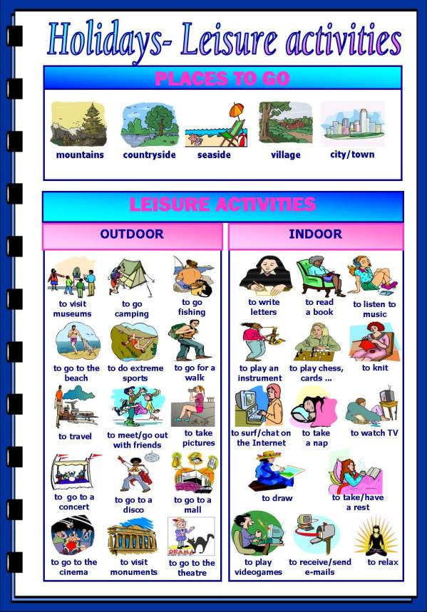

Task 2: Дополни предложения, используя форму going to с глаголами в рамке.
Play celebrate make spend start not go not take not have

- Mark ____________ the piano at the school concert next week.
- Mary´s mum ____________ a new job next week.
- I ____________ a party for my birthday this year.
- Mum ____________ me a cake for my birthday party next week.
- Alan and John ____________ their birthday next weekend.
- Dad ____________ to work on Tuesday.
- I ____________ two weeks with my grandparents in the country.
- We ____________ the train tomorrow.
Task 3: Расскажите о своих планах на выходные.
What are your plans for the next weekend?
Start like this: Next weekend I’m going to the mountains/ seaside/beach……
Task 4: Перед прослушиванием текста сопоставьте слова с их значением.
- Smoker ( ) to make a noisy sucking sound while drinking
- To slurp ( ) slightly angry
- Noodles ( ) drivers
- To quit ( ) someone who smokes cigars or cigarettes
- To leave sth around ( ) to tell someone something they don’t know
- Annoyed ( ) to stop doing something
- Motorists ( ) food cooked in boiling water
- Perhaps ( ) lo leave something somewhere carelessly
- To point out ( ) maybe

Task 5: Прослушайте текст, заполните пропуски.
What ______________________ habits? I think everyone has bad habits. Not everyone ______________________ what bad habits are. Some smokers don’t think smoking is a bad habit. Young people don’t think listening ______________________ on the train is a bad habit. In Japan, slurping your noodles ______________________ that you enjoy your food, but making a noise while eating in England ______________________. Have you ever tried to break your bad habits? I ______________________ smoking and have stopped leaving things laying ______________________ house. I wish other people would stop their bad habits. I get annoyed when people ______________________ meetings or talk loudly on their phones in public. I also think ______________________ need to think about their driving habits. Perhaps I should ______________________ their bad habits.

Task 6: Look at these bad habits. Do you have any of them?
  - always arriving late
  - sleeping too much
  - fast eating
  - watching too much TV
  - becoming an “owl” at night
  - nail biting
  - skipping breakfast
  - always carrying a heavy bag
  - drinking alcohol
  - being “superconnected”
  - being in love with junk food
  - smoking
  - drinking too much coffee
  - wearing headphones for hours
  - cursing
Task 7: Ответьте на вопросы в парах.
- Which bad habit do you think is the most difficult to get rid of?
- Are we born with our bad habits? Or do we acquire them?
- Do other people’s bad habits get on your nerves?
- What bad habits do you observe in your family members?
- Have you been successful in getting rid of a bad habit?
Критерии оценивания:
Выполнение заданий 1,2,3 низкого уровня – отметка «3».
Дополнительное выполнение задания 4,5,6 среднего уровня - отметка «4».
Дополнительное выполнение задания 7 высокого уровня - отметка «5».

Практическая работа №12 по теме «Времена группы Simple»
Цель: обобщить полученные знания по теме, практиковать в употреблении времён группы Simple.
Task 1: Составьте предложения из данных слов, в скобках укажите время.
I – dog – yesterday – washed – my
I washed my dog yesterday (Past Simple)
1. never – go – Sundays – shopping – on - we
2. ice-cream – likes – a – lot – he – of – eat - to
3. you – school – went – to – yesterday
4. it – tomorrow – very – will – rainy – be
5. made – Johnny – last – test – week – a
6. mow – Tommy – grass – the – will – Saturday – next
7. eat – chocolate – likes – she – to
8. going to – car – wash – the - is – she
10. worked – computer – he – on – the – last night
Task 2: Трансформируйте предложения из задания 1 в вопросительные, дайте краткие ответы.
- Did I wash my dog yesterday? 1.Yes, I did
- _________________________________ 2.No, ____________________________
- _________________________________ 3. No,____________________________
- _________________________________ 4. Yes,____________________________
- _________________________________ 5. No, ____________________________
- _________________________________ 6. No, ____________________________
- _________________________________ 7. Yes,_____________________________
- _________________________________ 8. Yes,_____________________________
9. ___________________________________ 9. No,_____________________________
10.___________________________________ 10. Yes,____________________________
Task 3: Составьте предложения из предложенных слов во всех временах группы Simple.
1. song – last week – sang
I sang a song last week (past)
I sing a song every day (present)
I will sing a song tomorrow (future)
1. garden – play – will
2. videogame – buy – I
3. milk – drink
4. homework – did
5. see – friends
Task 4: Задайте вопрос, замените подлежащее личным местоимением.
My brother watched T.V yesterday.
Did he watch T.V yesterday?
- Our teacher taught us the past tense last week.
__________________________________?
- My nephew spent all his money today.
__________________________________?
- My friend and I went to the bookstore this morning.
__________________________________?
- My classmates are very noisy during English class.
_________________________________?
- Your friends saw a movie last Saturday.
________________________________?
- His sister forgot to bring her schoolbag today.
________________________________?
7. Masato read a book about Japan yesterday.
________________________________?
8. John and Sandra begged for a present last week.
________________________________?
9. Silvia saw a big spider in her room.
________________________________?

Task 5: Дополните предложения по смыслу, используя данные глаголы
go – complain – buy - cry – listen – write – read – go - read – meet – do – buy
1. I _____________ to China last week.
2. He _________________ a letter to his girlfriend tomorrow.
3. They ________________ a book about the American history last week.
4. My mother ___________ the dishes every day.
5. My father ____________ Tokyo two weeks ago.
6. Yesterday I_______________ to the owner of the restaurant.
7. My friend _______________ a CD this morning.
8. My other friend ____________ to a CD in the evening.
9. My sister _______________ a friend tonight.
10. I _______________ once in a while.
Критерии оценивания:
Выполнение заданий 1,2,3 низкого уровня – отметка «3».
Дополнительное выполнение задания 4 среднего уровня - отметка «4».
Дополнительное выполнение задания 5 высокого уровня - отметка «5».

Практическая работа №13 «Questions»
Цель: научить образовывать общие, специальные, альтернативные, разделительные вопросы и вопрос к подлежащему и употреблять их в речи.
Task 1: Образуйте общий вопрос к данным предложениям.
1. Their classes will last till four o'clock tomorrow.
2. I had an early morning call at seven o'clock.
3. Little children like to ask many questions.
4. He translates a lot of letters into English.
5. I've already done this task.
6. She spends a lot of time on her English.
7. My children are at college.
8. They had supper at 7 o'clock.
9. I am going to play tennis in the evening.
10. They were writing when I came.
11. She can play the guitar very well.
12. There are many people in the library now.
13. Brazil won the football World Cup in 1994.
14. He has already read a lot of English books.
15. They have classes at 9 every day.
Task 2: Образуйте специальные вопросы к данным предложениям, количество вопросов указано в скобках.
1. My working day lasts eight hours. (3)
2. They discussed a lot of articles on economics last weekend. (6)
3. I have read this book in the original. (3)
4. They were watching TV when I came. (4)
5. I was absent because I was ill. (2)
6. It took me two hours to get there. (2)
7. They are going to travel by car. (3)
8. I always speak English to him. (3)
10. I taught him to swim. (3)
Task 3: Образуйте разделительные вопросы к данным предложениям.
1. They will return in a month.
2. Let's buy a loaf of bread.
3. Open the window.
4. I am late.
5. There is a theatre in the centre of the city.
6. She has never been to the Zoo.
7. I am right.
8. Don't go there.
9. Peter and Ann know English well.
10. He didn't do his homework.
11. Let's go to the country.
12. There were no mistakes in his dictation.
13. She won't be playing the piano at twelve.
14. They can't speak German at all.
15. She knows him.
Task 4: Образуйте альтернативные вопросы, количество вопросов указано в скобках.
1. The film was exciting (2).
2. Thousands of people visited the exhibition (2)
3. He watches TV every day. (3)
4. They can go to the country on Friday. (3)
5. She has painted the walls. (3)
Task 5: Составьте из предложенных слов специальный вопрос.
1. time, his, always, who, in, is, lessons, for?
2. going, a, what, her, about, he, week, is, to, in, write, to?
3.about, did, speak, last, in, what, week, class, you?
4. this, you, read, how, month, books, have, many?
5. people, the, to, at, prefer, sometimes, do, study, why, library?
6. many, France, he, been, how, to, times, has?
7. kind, brave, we, of, call, people, what, do?
8. draws, which, them, well, of?
Критерии оценивания:
Выполнение заданий 1,2,3 низкого уровня – отметка «3».
Дополнительное выполнение задания 4 среднего уровня - отметка «4».
Дополнительное выполнение задания 5 высокого уровня - отметка «5».

