**Содержание**

Пояснительная записка 4

Практическая работа № 1 «My Summer Holidays» 5

Практическая работа № 2 «Plural Nouns». 6

Практическая работа № 3 «Pronouns» 8

Практическая работа № 4 «My Family» 9

Практическая работа № 5 «Describing people» 11

Практическая работа № 6 «Prepositions» 14

Практическая работа № 7 «Конструкция there is/are» 15

Практическая работа № 8 «Present Simple» 17

Практическая работа № 9 «Past Simple» 19

Практическая работа № 10 «Future Simple» 21

Практическая работа № 11 «My Hobby» 23

Практическая работа № 12 по теме «Времена группы Simple» 26

Практическая работа № 13 «Questions» 29

Практическая работа № 14 «Canada» 31

Практическая работа № 15 «Australia» 33

Практическая работа № 16 «English speaking countries» 36

Список литературы 43

# Пояснительная записка

Дидактический материал предназначен студентам I курса, обучающихся в Сургутском политехническом колледже, для работы на учебном занятии по дисциплине «Иностранный язык», может быть использован в процессе организации повторения и промежуточного контроля изученного материала на уроках английского языка и индивидуальных занятиях с учащимися на консультациях.

Пособие включает основные темы, посвященные различным разделам дисциплины. В каждой практической работе обозначена цель, сформулированы задания разной степени сложности, разработаны критерии оценивания. Данный подход позволяет учащемуся самостоятельно определить для себя уровень сложности практической работы, что обеспечивает реализацию индивидуального подхода при использовании данного пособия.

В сборнике представлены различные типы практических заданий для развития и совершенствования коммуникативных умений учащихся по английскому языку в четырех основных видах речевой деятельности (аудирование, чтение, говорение, письмо), а также для отработки лексических и грамматических навыков. К текстам разработаны коммуникативные задания, побуждающие учащихся к беседе по темам страноведческого цикла. В пособие вошли задания грамматические, коммуникативные, письменные, устные, также предлагаются кроссворды и задания для викторины. Задания снабжены иллюстрациями, что делает их более привлекательными для учащихся.

В основе разработанного пособия лежат общедидактические принципы обучения иностранным языкам:

* воспитывающего обучения;
* сознательности;
* активности;
* наглядности;
* доступности и посильности;
* прочности навыка;
* индивидуализации.

### Практическая работа № 1 «My Summer Holidays»

**Цель:** практиковать студентов в употреблении лексики по теме, формировать и совершенствовать произносительные и речевые навыки, развивать языковую догадку.

**Task 1: Прочтите предложения, к словам, выделенным жирным шрифтом, подберите противоположные по значению слова из предложенных.**

Boring, unsuitable, disgusting, ordinary, terrible, stressful

1. The Riverdale Campsite is **ideal** for families with young children.

2. We had a **fantastic** time at the funfair.

3. Last year we had a very **relaxing** holiday.

4. I read a really **interesting** book last week.

5. The buildings in the city are quite **extraordinary**.

6. The food at that restaurant is **delicious**.

**Task 2: Образуйте предложения по образцу.**

**You can pitch a tent at a campsite.**

Pitch a tent, have dinner, watch a play, admire paintings, take a ride on a roller-coaster, relax by the swimming pool, order dessert, buy art posters, make a camp fire, call for room service, walk through a haunted house, watch a musical.

**Task 3: Заполните пропуски данными прилагательными по смыслу.**

**stormy, sunny, cloudy, snowy, rainy, windy**

1. It was a ..…… day in the middle of January so we made a snowman.

2. It was such a ……. day that my umbrella was blown inside out.

3. Most people like to go on holiday when it is hot and …… .

4. Half an hour later the weather became very ……… . They could hear the rumble of thunder and they saw flashes of lightening across the sky.

5. On a … night you can't see any stars in the sky.

6. The … town's river overflows every year during the season.

**Task 4:** Сопоставьте информацию из колонок А и В таблицы на стр. 6, затем образуйте предложения по образцу

***A sleeping bag is something, which you sleep in when you go camping.***

|  |  |
| --- | --- |
| **A** | **B** |
| 1) sleeping bag | a) You can sit in hot steam in there. |
| 2) maid | b) It keeps food cold. |
| 3) stadium | с) He serves meals. |
| 4) cooler | d) You can enjoy a delicious meal there. |
| 5) receptionist | e) She cleans rooms. |
| 6) sauna | f) You sleep in it when you go camping. |
| 7) restaurant | g) You can watch a football match there. |
| 8) compass | h) Не/She welcomes guests at a hotel. |
| 9) sun cream | i) It protects your skin from the sun. |
| 10) waiter | j) It helps you find directions. |

**Task 5: Ответьте на вопросы.**

1. Where did you spend your holidays?( in a summer camp, in the country, at home, at the seaside)
2. What did you do there? (read books, work in the garden, go for walks, fly a kite, swim in the sea, go hiking, earn money, have a picnic, watch TV, make barbecue, go fishing, lie in the sun, play computer games, walk in the park, help your grandparents, take a photo)
3. What was the weather like? (sunny, cold, hot, rainy, windy, fine, brilliant)
4. Whom did you go there with? (with my parents, with my friends, alone)

**Критерии оценивания:**

Выполнение заданий 1, 2, 3 низкого уровня – отметка «3».

Дополнительное выполнение задания 4 среднего уровня – отметка «4».

Дополнительное выполнение задания 5 высокого уровня – отметка «5».

### Практическая работа № 2 «Plural Nouns».

**Цель:** формировать грамматический навык – научить образовывать и употреблять в речи существительные во множественном числе.

**Task 1: Поставьте следующие существительные во множественное число.**

a. diary –

b. sheep –

c. book –

d. cherry –

e. fish –

f. baby –

g. key –

h. match –

i. bus –

j. watch –

**Task 2: Напишите во множественном числе существительные исключения.**

a. woman –

b. mouse –

c. tooth –

d. foot –

e. man –

f. child –

g. goose –

h. ox –

**Task 3: Поставьте следующие существительные в единственное число.**

a. glasses –

b. potatoes –

c. forget-me-nots –

d. crises –

e. stimuli –

f. foxes –

g. brushes –

h. brothers-in-law –

i. phenomena –

j. formulae –

k. data –

**Task 4: Найдите 10 слов в множественном числе.**

|  |  |  |  |  |  |  |  |  |  |
| --- | --- | --- | --- | --- | --- | --- | --- | --- | --- |
| J | O | P | F | T | U | Y | K | L | Q |
| R | G | E | G | O | I | P | F | E | D |
| E | F | N | F | G | H | J | I | P | W |
| F | A | C | E | S | M | N | S | O | O |
| A | Y | I | A | D | C | V | H | F | M |
| M | T | L | F | E | E | T | Q | L | E |
| I | P | S | T | I | M | U | L | I | N |
| L | O | B | O | O | E | I | A | E | I |
| I | M | N | Y | L | N | L | S | S | U |
| E | B | L | M | P | K | R | D | Z | P |
| S | G | I | R | L | S | W | X | B | M |

**Task 5: Найдите 5 существительных во множественном числе в тексте.**

[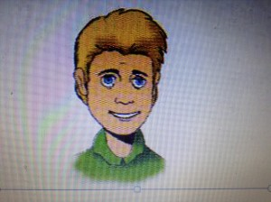](http://englisch-infoblog.ru/wp-content/uploads/2013/08/IMG_0197) Hi! My name’s Bob. I’m 16 years old and I live in London. I’m tall and slim. I’ve got blond hair and blue eyes. These are my best friends, Tony and Simon.

[](http://englisch-infoblog.ru/wp-content/uploads/2013/08/IMG_0203)

Tony is 17 years old and he is a football player. He always watches football matches on TV.

[](http://englisch-infoblog.ru/wp-content/uploads/2013/08/IMG_0202)

Simon is 16 years old. He’s short and plump, but very funny. He likes listening to music and play computer games.

**Критерии оценивания:**

Выполнение заданий 1, 2, 3 низкого уровня – отметка «3».

Дополнительное выполнение задания 4 среднего уровня – отметка «4».

Дополнительное выполнение задания 5 высокого уровня – отметка «5».

### Практическая работа № 3 «Pronouns»

**Цель:** практиковать студентов в употреблении местоимений, формировать и совершенствовать произносительные и речевые навыки, развивать языковую догадку.

**Task 1: Заполните пропуски, используя притяжательные местоимения (my, your, his, her, our, their).**

1. I left … car in the garage.

2. Mary hung … coat on the peg.

3. Jack had … hair cut.

4. Neil and David ate … supper.

5. I hope you enjoy … holiday.

**Task 2: Заполните пропуски, используя личные и возвратные местоимения.**

1. He is quite right, I agree with … completely.

2. I looked at … in the mirror and left the house in a very good mood.

3. “Who is it?” – “It’s … may I come in?”

4. Mr. Lloyds is very fat. … weighs over a hundred kilos?

5. … introduced his wife to the quests.

**Task 3:** **Употребите подходящее по смыслу притяжательное местоимение.**

***1. my      2. your       3. his      4. her      5. its       6. our     7. their***

1. Mr. and Mrs. Brown have two children. Both ... children are boys.

2. Miss Smith is a teacher. ... students are Germans.

3. We are French. ... friends are English.

4. You are in Bristol, but ... family is in York.

5. I have a small cat. ... cat is very funny.

6. My daughter has a dog. ... nose is long.

7. My friends have a new car. ... car is very nice.

8. Mary has a new bag. ... bag is very big.

**Критерии оценивания:**

Выполнение заданий 1, 2 – отметка «3».

Дополнительное выполнение задания 3 – отметка «4», «5».

### Практическая работа № 4 «My Family»

**Цель:** научить рассказывать о своей семье, используя лексику урока, образовывать отрицания и задавать вопросы по теме.

**Task 1: Разгадайте кроссворд на стр. 10**

**Task 2: Посмотрите на фамильное древо, скажите кто кому кем приходится.**

1. Anne and Paul are _____________
2. Anne is Paul’s _____________
3. Paul is Anne’s _____________
4. Anne and Paul have _____________, _____________ and a _____________
5. Anne and Paul have _____________
6. Anne and Paul are Miranda’s _____________
7. Stella is Nick’s _____________
8. Carl is Brien’s _____________
9. Chris and Claudia are _____________
10. Mary is Claudia’s _____________
11. 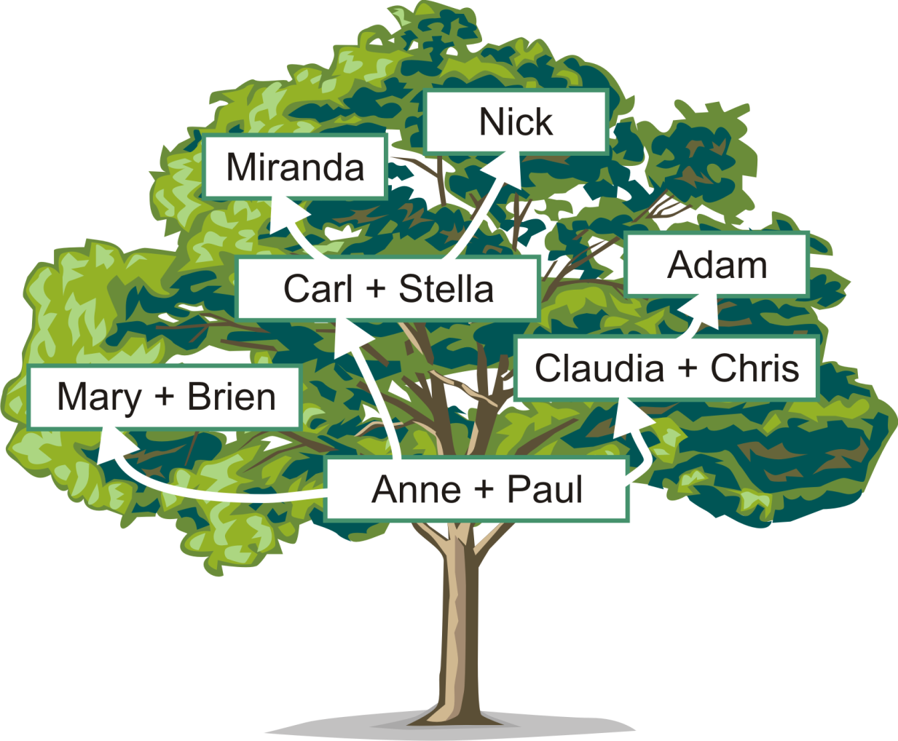Adam is Claudia’s _____________

кр семья 1

6. My mother’s husband is my …

1. My mother’s mother is my …

7. My mother’s daughter is my …

2. My father and my mother are my …

3. My brother’s son is my …

g0407708

8. My brother is my mother’s …

5. My father’s wife is my …

4. My mother is my father’s …

g0407690g0407704g0407722g0407718

**FAMİLY CROSSWORD**

**Task 3: Ответьте на вопросы.**

1. What is your name?

2. What is your mother’s name?

3. What is your father’s name?

4. Have you got sisters/brothers? What is her/his name?

5. Have you got a boyfriend/girlfriend? What is his/her name?

6. What is your mother’s mother name? She is your …… What is her husband’s name? He is your …..

7. What is your father’s father name? He is your …. What is his wife’s name? She is your ….

8. Have you got uncles and aunts? Whose brothers/sisters are they? Want are their names?

9. Have you got cousins? What are their names? Whose sons/daughters are they?

**Критерии оценивания:**

Выполнение заданий 1, 2 – отметка «3».

Дополнительное выполнение задания 3 – отметка «4», «5».

### Практическая работа № 5 «Describing people»

**Цель:** научить описывать людей, используя лексику урока, образовывать отрицания и задавать вопросы по теме.

**Task 1:** **Попробуйте догадаться о значении данных слов и выражений.**

**hair**

|  |  |
| --- | --- |
| straight | wavy |
| curly | thick |
| thin | short |
| shoulder-length | blond |
| ginger | grey |
| braids | dreadlocks |
| balding | bald |

**facial hair**

|  |  |
| --- | --- |
| a moustache | a beard |
| a 5 o’clock shadow/stubble | thick/thin eyebrows |
| thick/thin lips | a wide/narrow nose |
| small/big eyes | a long/round/oval/squared face |
| a long/small chin |  |

**Task 2: Задайте вопрос и ответьте на него, работайте в парах.**

- What does Ilya look like?

- What does Anya look like? etc.

**Task 3: Игра «Угадай, кто я?»**

Work in pairs or in 2 groups.

Student A thinks of a person, Student B will have to ask yes/no questions to find out who they are thinking of. (Guess who game)

- Is it a man? Has he got a moustache?...

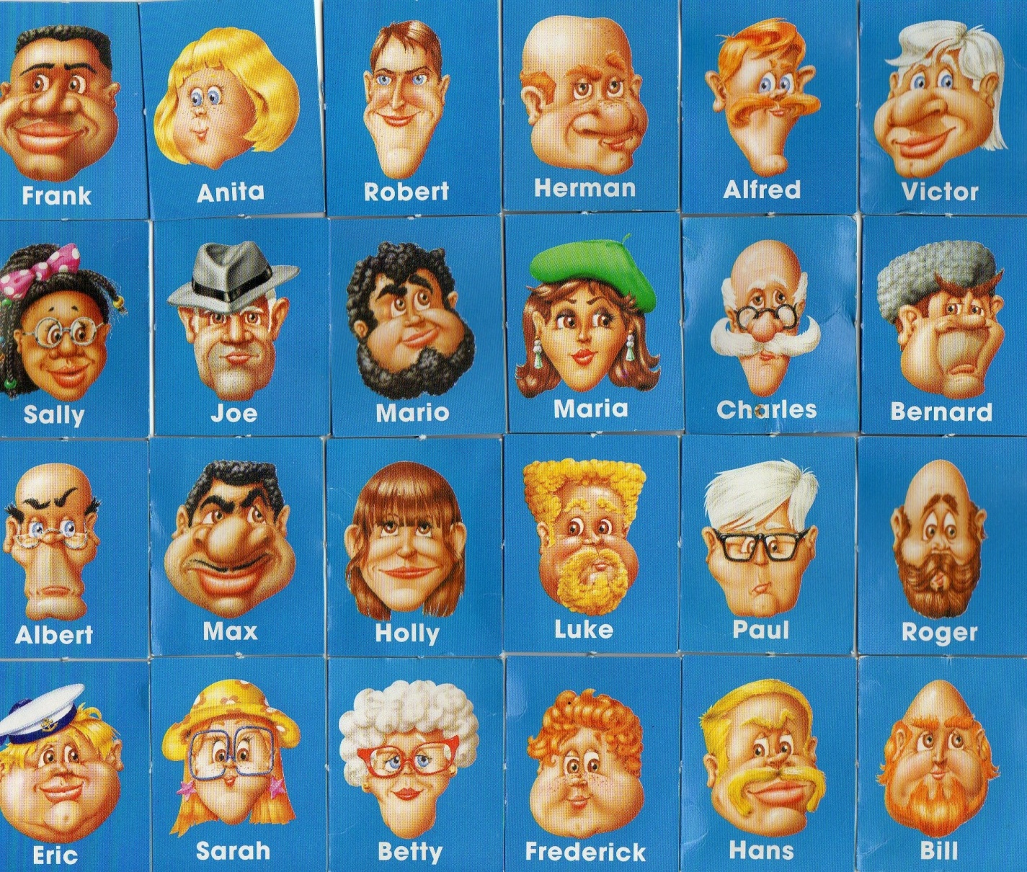

**Task 4: Выберите трёх знаменитых людей и опишите их, используя информацию из таблицы.**

1 ___________________________________________

2 ___________________________________________

3 ___________________________________________

|  |  |  |  |
| --- | --- | --- | --- |
|  | Famous 1 | Famous 2 | Famous 3 |
| Nationality |  |  |  |
| Age |  |  |  |
| Face |  |  |  |
| Skin colour |  |  |  |
| Hair colour |  |  |  |
| Height |  |  |  |
| Famous for…..? |  |  |  |

Describe your famous people. Can your partner guess who are they?

Pick a famous person you’d like to be friends with. Why?

**Task 5: Выберите человека, о котором вам хотелось бы рассказать, и ответьте на вопросы.**

* 1. Where does s/he live?
  2. What does s/he do?
  3. How does s/he look like?
  4. Why do you like this person?
  5. Do you know what does s/he like doing?
  6. Why do you like this person?
  7. Do you think you could be friends? Why?
  8. Do you remember his or her last performance?
  9. If your famous person acts, what kind of movie would you like to film with him/her?

**Критерии оценивания:**

Выполнение заданий 1, 2, 3 низкого уровня – отметка «3».

Дополнительное выполнение задания 4 среднего уровня – отметка «4».

Дополнительное выполнение задания 5 высокого уровня – отметка «5».

### Практическая работа № 6 «Prepositions»

**Цель:** научить правильно употреблять в речи предлоги времени места и направления.

**Task 1: Вставьте предлоги *at*или *on.***

1. I get up ... seven o'clock or ... a quarter past seven.

2. ... Sunday I usually get up ... nine o'clock or half past nine. But last Sunday I slept very long and got up only ... noon.

3. Lev Tolstoy liked to get up... sunrise.

4. Our lessons are usually over ... twenty minutes to two.

5. They returned from the wood... sunset.

6. I began writing my composition ... seven o'clock and finished only ... midnight.

7. My birthday is ... the ninth of July.

8. The school year begins ... the first of September.

9. ... the twenty-fifth of December people celebrate Christmas.

10. ... Wednesday I usually have a lot of homework.

**Task 2: Вставьте предлоги *on, in*или *into.***

1. Where is the book?  It is ... the table.

2. Where is the tea? It is ... the cup.

3. Put the plates ... the table.

4. Put the book ... the bag.

5. There is a beautiful picture ... the wall.

6. He went ... the room.

7. I like to sit ... the sofa ... my room.

8. Mother is cooking dinner ... the kitchen.

9. She went ... the room and sat down ... the sofa.

10.  There are many people ... the park today.

**Task 3: Вставьте предлоги *in*или to.**

1. We did not want to stay ... town on such a hot day, so we went ... the country.

2. It is very late: Go ... bed at once.

3. Where is your little sister? She is ... bed. Mother always puts her ... bed at eight o'clock.

4. In summer my mother does not go ... work and I don't go ... school. We live ... the country. My father goes ... work every day, so he stays ... town. But sometimes he comes ... the country after work and goes back ... town early in the morning, when I am still ... bed.

5. In winter I usually go ... bed at ten o'clock because I learn ... school and have to get up early.

**Task 4: Вставьте предлоги, где необходимо.**

1. My mother is afraid ... rats.

2. "What do you complain ...?" asked the doctor.

3. Don't enter ... the room.

4. What are you laughing ... ?

5. They did not want to listen ... me.

6. Wait ... me. I'll be back ... a few minutes.

7. Yesterday the teacher spoke ... us about the architecture ... St. Peters­burg.

8. My grandmother often complains ... headache.

9. I am sorry, I cannot speak ... you now, the professor is waiting ... me. I must go ... the institute and explain ... him some details ... our work. Come ... the evening, I shall listen ... you very attentively and answer ... all your questions.

10. ... nine o'clock the lecturer entered ... the hall, walked up ... the table, put his bag ... it, looked .... everybody and began his lecture. The lecture, as all the lectures ... this professor, was very interesting, and the students listened ... him with great attention.

**Task 5: Переведите на английский язык, употребляя предлоги *to*или *into.***

1. Иди в парк.

2. Войди в парк.

3. Она пошла в кухню.

4. Она вошла в кухню.

5. Не ходите в магазин.

6. Не входите в магазин.

7. Она побежала во двор.

8. Она вбежала во двор.

9. Я пошел в сад.

10. Я вошел в сад.

11. Мы пошли в лес.

12. Мы вошли в лес.

13. Идите в класс.

14. Войдите в класс.

**Критерии оценивания:**

Выполнение заданий 1, 2, 3 низкого уровня – отметка «3».

Дополнительное выполнение задания 4 среднего уровня – отметка «4».

Дополнительное выполнение задания 5 высокого уровня – отметка «5».

### Практическая работа № 7 «Конструкция there is/are»

**Цель:** научить правильно употреблять в речи оборот There is/ there are, образовывать отрицания и задавать вопросы, используя этот оборот.

**Task 1:** **Вставьте правильную форму глагола to be.**

1. There... two women in the room.

2. There... a dog and a cat in the house.

3. There... a boy and two girls at the blackboard.

4. There... four people in my family.

5. There... a lot of people in the laboratory.

6. There... a time-table and a lot of notice-boards near the Dean’s office.

7. There... no news from my friend.

8. There... a lot of books on the shelf.

**Task 2:** **Поставьте следующие предложения в вопросительную и отрицательную формы.**

1. There were two faculties at the college.

2. There is a post-graduate department at our college.

3. There will be three new schools in the town.

4. There was a dictionary and two newspapers on the table.

5. There is a number of bookshelves in the classroom

6. There will be a new bus station in our town.

7. There were 25 students in my class.

**Task 3: Поставьте следующие предложения в прошедшее время, добавив соответствующее обстоятельство времени.**

1. There is one theatre in our town.

2. There are two faculties at our college.

3. There is a bus stop near my house.

4. There are many people in the park.

5. There is a delegation in the museum.

6. There are three shops in our street.

**Task 4: Исправьте ошибку, если она есть.**

1. There are a lot of salt in the soup.
2. There are some good programs.
3. There is a lot of computers in our college.
4. There is much water outside.
5. There is a good dictionary in the library.

**Task 5: Прочитайте два текста и запишите к ним вопросы, используя обороты there + to be**

Donna Walton.

Donna’s an English teacher. She’s not rich and she’s not famous. Her house is small and there’s no pool. There are three bedrooms in the house. Donna’s car is old. It’s slow and uncomfortable. There’s no radio or cassette player in her car. There’s an engine, a steering wheel, and there are four wheels and two doors. Donna isn’t happy. She’d like a big house, a new car and a lot of money.

Zack Zebedee.

Here is a rock star. He’s very rich and famous. His house is large and there’s a swimming pool in the backyard. There are ten bedrooms in the house. Zack’s car is new. It’s fast and comfortable. In his car there is a climate control system, a CD player, a VCR, a phone and fax machine. But Zack is not happy. He’d like a small house, a small car and a family with two kids.

Образец:

1. Is there a pool near the house?
2. Are there two doors in his car?

**Критерии оценивания:**

Выполнение заданий 1, 2, 3 низкого уровня – отметка «3».

Дополнительное выполнение задания 4 среднего уровня – отметка «4».

Дополнительное выполнение задания 5 высокого уровня – отметка «5».

### Практическая работа № 8 «Present Simple»

**Цель:** научить правильно употреблять в речи Present Simple, образовывать отрицания и задавать вопросы, используя данное время.

**Task 1: Поставьте глаголы в следующих предложениях в утвердительную, вопросительную и отрицательную формы Present Simple.**

1. I (to do) morning exercises.

2. He (to work) at a factory.

3. She (to sleep) after dinner.

4. We (to work) part-time.

5. They (to drink) tea every day.

6. Mike (to be) a student.

7. Helen (to have) a car.

8. You (to be) a good friend.

9. You (to be) good friends.

10. It (to be) difficult to remember everything.

**Task 2: Раскройте скобки, употребляя глаголы в Present Simple.**

1. Alice (to have) a sister.

2. Her sister’s name (to be) Ann.

3. Ann (to be) a student.

4. She (to get) up at seven o'clock.

5. She (to go) to the institute in the morning.

6. Jane (to be) fond of sports.

7. She (to do) her morning exercises every day.

8. For breakfast she (to have) two eggs, a sandwich and a cup of tea.

9. After breakfast she (to go) to the institute.

10. Sometimes she (to take) a bus.

11. It (to take) her an hour and a half to do her homework.

12. She (to speak) English well.

13. Her friends usually (to call) her at about 8 o’clock.

14. Ann (to take) a shower before going to bed.

15. She (to go) to bed at 11 p. m.

**Task 3: Раскройте скобки, употребляя глаголы в** **Present Simple.**

1. My working day (to begin) at six o'clock.

2. I (to get) up, (to switch) on the TV and (to brush) my teeth.

3. It (to take) me about twenty minutes.

4. I (to have) breakfast at seven o’clock.

5. I (to leave) home at half past seven.

6. I (to take) a bus to the institute.

7. It usually (to take) me about fifteen minutes to get there.

8. Classes (to begin) at eight.

9. We usually (to have) four classes a day.

10. I (to have) lunch at about 2 o’clock.

**Task 4: Вставьте глагол “to be” в требуемой форме Present Simple.**

1. I ... a student.

2. My father ... not a shop-assistant, he ... a scientist.

3. ... your aunt a nurse? - Yes, she ... .

4. ... they at home? - No, they ... not. They ... at school.

5. ... you an engineer? - Yes, I....

6. ... your friend a photographer? No, she ... not a photographer, she ... a student.

7. ... your brothers at school? - Yes, they ... .

8. ... this her watch? - Yes, it ... .

9. Max ... an office-worker.

10. We ... late, sorry!

**Task 5: Используйте слова в скобках для образования предложений в Present Simple. Обратите внимание, в какой форме должно стоять предложение (утвердительной, вопросительной или отрицательной).**

1. They _____ football at the institute. (to play)

2. She _____ emails. (not / to write)

3. ____ you____ English? (to speak)

4. My mother ____ fish. (not / to like)

5. ____ Ann ____ any friends? (to have)

6. His brother _____ in an office. (to work)

7. She ___ very fast. (cannot / to read)

8. ____ they ____ the flowers every 3 days? (to water)

9. His wife _____ a motorbike. (not / to ride)

10. ____ Elizabeth_____ coffee? (to drink)

**Критерии оценивания:**

Выполнение заданий 1, 2, 3 низкого уровня – отметка «3».

Дополнительное выполнение задания 4 среднего уровня – отметка «4».

Дополнительное выполнение задания 5 высокого уровня – отметка «5».

### Практическая работа № 9 «Past Simple»

**Цель:** научить правильно употреблять в речи The Past Simple, образовывать отрицания и задавать вопросы, используя данное время.

**Task 1: Выберите подходящее время (Present или Past) глагола в зависимости от контекста и лексических указателей, которые помогут определить наиболее подходящий вариант.**

1. He … (go) to Africa in 1995 and he … (like) that trip very much.
2. My sister usually … (like) her steak well-done.
3. The cat … (eat) its toy last evening.
4. The doctor … (talk) to his patient on Monday morning.
5. … they … (have) a test last month?
6. I often … (see) his brother but he never … (speak) to me.
7. The director … (speak) to the employees three hours ago.
8. The man … (domesticate) the dog many years ago.
9. My friend … (spend) a lot of money every day.
10. The woman … (drive) to the shop last Sunday.
11. My parents … (leave) for Paris last Thursday.
12. His brother … (leave) for Tokyo every August.
13. I don’t like my boss because he often … (raise) voice at me.
14. Her mother never … (drink).
15. The cat usually … (leave) its house when it’s thirsty or hungry.

**Task 2: Задание, идентичное предыдущему. При его выполнении обратите особое внимание на слова-маркеры (сигнальные слова), которые помогут вам сделать правильный выбор между Present и Past.**

1. Every day Peter … (clean) his room.
2. Yesterday Peter … (wash) the dishes.
3. Ann and Mary usually … (help) their parents.
4. The pupils of our class … (rake) all the leaves last autumn.
5. Most of the families … (take) out their trash every week.
6. Children … (wash) the windows today.
7. My grandmother always … (prepare) the breakfast.
8. Kate … (fold) the laundry two weeks ago.
9. We … (decorate) our house every winter.
10. Last Christmas she … (cook) a tasty Yule log.
11. My mother … (work) in the garden every spring.
12. These boys … (study) at school.
13. Children … (love) their parents.
14. My father … (make) a surprise for my last birthday.
15. My mother … (make) a surprise for my birthday every year.
16. Christina … (mop) the floor in her flat every Monday.
17. We … (water) the flowers two days ago.
18. Children … (like) to play in the yard.
19. Bob … (promise) to give up smoking two months ago.
20. Peter’s father … (work) in the hospital.

**Task 3: Дополните предложения, заменив пропуски соответствующей формой глагола, указанного в скобках.  В предложениях используются оба времени – и простое настоящее, и простое прошедшее.**

1. Every day Kate … (go) to work by tram. Yesterday morning she (wake) up early and … (decide) to walk.
2. Last week, Mr. Smith … (buy) a new house near his office. Every day he … (come) to the office at eight o’clock. He usually … (have) his dinner there too, but yesterday he … (go) home to eat.
3. Susan … (like) to go to the cinema on weekends very much. Last weekend she … (invite) her friends Peter and Helen to go and watch a new action film. The … (arrive) at the cinema around 19:30 and the film … (start) at 19:45.
4. Once a week, Christian … (play) football. But last week, he … (stay) at home and … (play) chess with his friend.

**Task 4: Вставьте глагол, указанный в скобках, вместо пропусков, предварительно поставив его в правильную форму.**

1. The swimming pool … (open) at 10 o’clock and … (close) at 19 o’clock every day.
2. … you … (go) out last night?
3. I don’t understand the meaning of the word ‘rehabilitation’. What … ‘rehabilitation’ … (mean)?
4. We all … (leave) his party at 11 o’clock.
5. In summer Peter usually … (play) tennis twice a week.
6. Yesterday I … (go) to Paris to see a friend of mine.
7. How many languages … you … (speak)?
8. The policeman … (stop) me on my way home last night.
9. We … (invite) them to the party last week but they … (decide) not to come.
10. What time … the shops … (close) in London?

**Task 5: Перепишите следующий текст в прошедшем времени (вот, что рассказала мама).**

On Tuesday I get up at half past six. I go to the bathroom, wash my hands, face, and clean my teeth. Then I dress, go to the kitchen and cook breakfast for my family. At half past seven my son gets up and has breakfast. I have breakfast with my son. My son eats a sandwich and drinks a cup of tea. I don't drink tea. I drink coffee. After Breakfast my son leaves home for college. I don't leave home with my son. On Tuesday I don't work in the morning. I work in the afternoon. In the evening I am at home. My husband and my son are at home, too. We rest in the evening. My son watches TV, my husband reads newspapers and I do some work about the house. At about eleven o'clock we go to bed.

**Критерии оценивания:**

Выполнение заданий 1, 2, 3 низкого уровня – отметка «3».

Дополнительное выполнение задания 4 среднего уровня – отметка «4».

Дополнительное выполнение задания 5 высокого уровня – отметка «5».

### Практическая работа № 10 «Future Simple»

**Цель:** научить правильно употреблять в речи The Future Simple, образовывать отрицания и задавать вопросы, используя данное время.

**Task 1: Раскройте скобки, употребляя глаголы в форме Future Simple.**

1. I (to be) very busy at the beginning of June. We (to have) our exams.

2. This day (to come) sooner or later.

3. Who (to join) me? Perhaps I (to drive) to town this weekend.

4. You (to help) me or not?

5. He (to come) to see me in a year’s time.

6. How long you (to be) away? I (to miss) you.

7. She (to have) dinner in ten minutes.

8. I think I (to get up) earlier tomorrow morning.

9. Alex (to help) her to pass her exam, I’m sure.

10. They (to write) a test tomorrow at their English lesson.

**Task 2: Раскройте скобки, употребляя глаголы в Present Simple или Future Simple. (Все предложения относятся к будущему).**

1. Before you (to cross) the park, you (to come) to a supermarket.

2. If I (to stay) some more days in your town, I (to call) on you and we (to have) a good talk.

3. After I (to finish) school, I (to enter) the University.

4. When he (to return) to Moscow, he (to call) on us.

5. If I (to see) him, I (to tell) him about their letter.

6. The child (not to be) healthy, if you (not to give) him much fruit.

7. I (to sing) you this song, if you (to tell) me the words.

8. If it (to be) very cold tonight, our car (not to start) in the morning.

9. I hope you (to join) us when we (to gather) in our country house the next time.

10. If the weather (to be) nice, we (to go) to the beach.

**Task 3: Раскройте скобки, употребляя глаголы в Present Simple или Future Simple. (Все предложения относятся к будущему).**

1. If he still (to have) a cold and (not to feel) better, he (not to go) to the theatre.

2. He (to ring) me up when he (to return) home.

3. Where they (to go) if the weather (to be) fine?

4. If we (to be) tired, we (to stop) in a small village halfway to the town and (to have) a short rest and a meal there.

5. If she (not to work) properly, her boss (to fire) her.

6. I am sure he (to come) to say goodbye to us before he (to leave) for the USA.

7. Before he (to start) to London, he (to spend) a week or two at a health resort not far from here.

8. If you (to decide) about your diet, you (to eat) wedding cake tomorrow.

9. What he (to do) when he (to come) home in the evening?

10. If we (to put) in cameras, they (to stop) people stealing things.

**Task 4: Составьте утвердительные предложения, используя to be going to.**

1. I / work

2. you / dance

1. it / rain
2. they / ask
3. he / stays
4. we / speak
5. I / give
6. she / try
7. they / help
8. he / push

**Task 5: Составьте вопросительные предложения, используя to be going to.**

1. (he / cook dinner / tonight)

1. (you / run / in the race)
2. (they / climb / that mountain)
3. (she / exercise / at the gym / in the afternoon)
4. (you / carry / that heavy box)
5. (computer / crash)
6. (we / eat / fish / tonight)
7. (he / play football / tomorrow)
8. (Lucy / call / a taxi)
9. (you / sing / a song / for us)

**Критерии оценивания:**

Выполнение заданий 1, 2, 3 низкого уровня – отметка «3».

Дополнительное выполнение задания 4 среднего уровня – отметка «4».

Дополнительное выполнение задания 5 высокого уровня – отметка «5».

### Практическая работа № 11 «My Hobby»

**Цель:** научить рассказывать о своём увлечении, практиковать в аудировании, образовывать отрицания и задавать вопросы по теме.

**Task 1: Посмотрите на картинки на стр. 24, расскажите о том, чем вы любите заниматься в свободное время.**

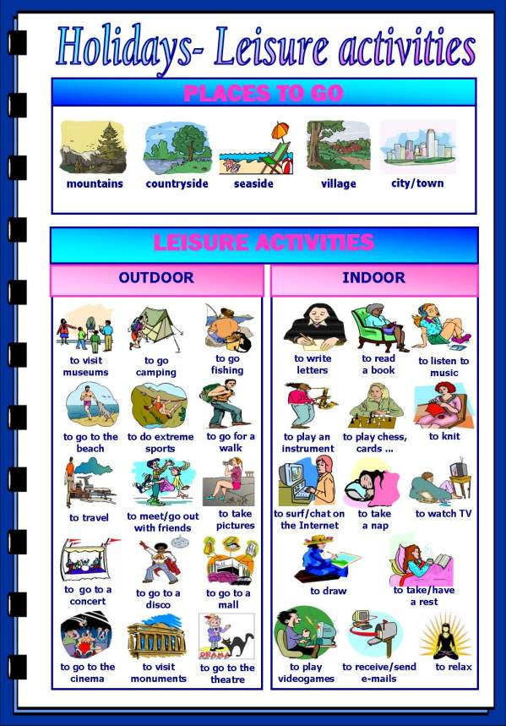

**Task 2:** **Дополни предложения, используя форму going to с глаголами в рамке.**

Play celebrate make spend start not go not take not have

1. Mark ____________ the piano at the school concert next week.
2. Mary´s mum ____________ a new job next week.
3. I ____________ a party for my birthday this year.
4. Mum ____________ me a cake for my birthday party next week.
5. Alan and John ____________ their birthday next weekend.
6. Dad ____________ to work on Tuesday.
7. I ____________ two weeks with my grandparents in the country.
8. We ____________ ­ the train tomorrow.

**Task 3: Расскажите о своих планах на выходные.**

What are your plans for the next weekend?

Start like this: Next weekend I’m going to the mountains/seaside/beach……

**Task 4: Перед прослушиванием текста сопоставьте слова с их значением.**

1. Smoker ( ) to make a noisy sucking sound while drinking
2. To slurp ( ) slightly angry
3. Noodles ( ) drivers
4. To quit ( ) someone who smokes cigars or cigarettes
5. To leave sth around ( ) to tell someone something they don’t know
6. Annoyed ( ) to stop doing something
7. Motorists ( ) food cooked in boiling water
8. Perhaps ( ) lo leave something somewhere carelessly
9. To point out ( ) maybe

**Task 5: Прослушайте текст, заполните пропуски.**

What ______________________ habits? I think everyone has bad habits. Not everyone ______________________ what bad habits are. Some smokers don’t think smoking is a bad habit. Young people don’t think listening ______________________ on the train is a bad habit. In Japan, slurping your noodles ______________________ that you enjoy your food, but making a noise while eating in England ______________________. Have you ever tried to break your bad habits? I ______________________ smoking and have stopped leaving things laying ______________________ house. I wish other people would stop their bad habits. I get annoyed when people ______________________ meetings or talk loudly on their phones in public. I also think ______________________ need to think about their driving habits. Perhaps I should ______________________  their bad habits.

**Task 6: Look at these bad habits. Do you have any of them?**

* + always arriving late
  + sleeping too much
  + fast eating
  + watching too much TV
  + becoming an “owl” at night
  + nail biting
  + skipping breakfast
  + always carrying a heavy bag
  + drinking alcohol
  + being “superconnected”
  + being in love with junk food
  + smoking
  + drinking too much coffee
  + wearing headphones for hours
  + cursing

**Task 7: Ответьте на вопросы в парах.**

1. Which bad habit do you think is the most difficult to get rid of?
2. Are we born with our bad habits? Or do we acquire them?
3. Do other people’s bad habits get on your nerves?
4. What bad habits do you observe in your family members?
5. Have you been successful in getting rid of a bad habit?

**Критерии оценивания:**

Выполнение заданий 1, 2, 3 низкого уровня – отметка «3».

Дополнительное выполнение задания 4, 5, 6 среднего уровня – отметка «4».

Дополнительное выполнение задания 7 высокого уровня – отметка «5».

### Практическая работа № 12 по теме «Времена группы Simple»

**Цель:** обобщить полученные знания по теме, практиковать в употреблении времён группыSimple.

**Task 1: Составьте предложения из данных слов, в скобках укажите время.**

*I – dog – yesterday – washed – my*

I washed my dog yesterday (Past Simple)

1. never – go – Sundays – shopping – on – we

2. ice-cream – likes – a – lot – he – of – eat – to

3. you – school – went – to – yesterday

4. it – tomorrow – very – will – rainy – be

5. made – Johnny – last – test – week – a

6. mow – Tommy – grass – the – will – Saturday – next

7. eat – chocolate – likes – she – to

8. going to – car – wash – the – is – she

10. worked – computer – he – on – the – last night

**Task 2: Трансформируйте предложения из задания 1 в вопросительные, дайте краткие ответы.**

1. Did I wash my dog yesterday? 1. Yes, I did
2. _____________________________ 2. No, __________________________
3. _____________________________ 3. No, __________________________
4. _____________________________ 4. Yes, __________________________
5. _____________________________ 5. No, __________________________
6. _____________________________ 6. No, __________________________
7. _____________________________ 7. Yes, __________________________
8. _____________________________ 8. Yes, __________________________

9.  _____________________________ 9. No, __________________________

10._____________________________ 10. Yes, _________________________

**Task 3: Составьте предложения из предложенных слов во всех временах группы Simple.**

1. song – last week – sang

I **sang** a song last week (past)

I **sing** a song every day (present)

I **will** sing a song tomorrow (future)

1. garden – play – will

2. videogame – buy – I

3. milk – drink

4. homework – did

5. see – friends

**Task 4: Задайте вопрос, замените подлежащее личным местоимением.**

My brother watched T.V yesterday.

Did he watch T.V yesterday?

1. Our teacher taught us the past tense last week.

__________________________________?

1. My nephew spent all his money today.

__________________________________?

1. My friend and I went to the bookstore this morning.

__________________________________?

1. My classmates are very noisy during English class.

_________________________________?

1. Your friends saw a movie last Saturday.

________________________________?

1. His sister forgot to bring her schoolbag today.

________________________________?

7. Masato read a book about Japan yesterday.

________________________________?

8. John and Sandra begged for a present last week.

________________________________?

9. Silvia saw a big spider in her room.

________________________________?

**Task 5: Дополните предложения по смыслу, используя данные глаголы**

go – complain – buy – cry – listen – write – read – go – read – meet – do – buy

1. I _____________ to China last week.

2. He _________________ a letter to his girlfriend tomorrow.

3. They ________________ a book about the American history last week.

4. My mother ___________ the dishes every day.

5. My father ____________ Tokyo two weeks ago.

6. Yesterday I_______________ to the owner of the restaurant.

7. My friend _______________ a CD this morning.

8. My other friend ____________ to a CD in the evening.

9. My sister _______________ a friend tonight.

10. I _______________ once in a while.

**Критерии оценивания:**

Выполнение заданий 1,2,3 низкого уровня – отметка «3».

Дополнительное выполнение задания 4 среднего уровня – отметка «4».

Дополнительное выполнение задания 5 высокого уровня – отметка «5».

### Практическая работа № 13 «Questions»

**Цель:** научить образовывать общие, специальные, альтернативные, разделительные вопросы и вопрос к подлежащему и употреблять их в речи.

**Task 1: Образуйте общий вопрос к данным предложениям.**

1. Their classes will last till four o'clock tomorrow.

2. I had an early morning call at seven o'clock.

3. Little children like to ask many questions.

4. He translates a lot of letters into English.

5. I've already done this task.

6. She spends a lot of time on her English.

7. My children are at college.

8. They had supper at 7 o'clock.

9. I am going to play tennis in the evening.

10. They were writing when I came.

11. She can play the guitar very well.

12. There are many people in the library now.

13. Brazil won the football World Cup in 1994.

14. He has already read a lot of English books.

15. They have classes at 9 every day.

**Task 2: Образуйте специальные вопросы к данным предложениям, количество вопросов указано в скобках.**

1. My working day lasts eight hours. (3)

2. They discussed a lot of articles on economics last weekend. (6)

3. I have read this book in the original. (3)

4. They were watching TV when I came. (4)

5. I was absent because I was ill. (2)

6. It took me two hours to get there. (2)

7. They are going to travel by car. (3)

8. I always speak English to him. (3)

10. I taught him to swim. (3)

**Task 3: Образуйте разделительные вопросы к данным предложениям.**

1. They will return in a month.

2. Let's buy a loaf of bread.

3. Open the window.

4. I am late.

5. There is a theatre in the centre of the city.

6. She has never been to the Zoo.

7. I am right.

8. Don't go there.

9. Peter and Ann know English well.

10. He didn't do his homework.

11. Let's go to the country.

12. There were no mistakes in his dictation.

13. She won't be playing the piano at twelve.

14. They can't speak German at all.

15. She knows him.

**Task 4: Образуйте альтернативные вопросы, количество вопросов указано в скобках.**

1. The film was exciting (2).

2. Thousands of people visited the exhibition (2)

3. He watches TV every day. (3)

4. They can go to the country on Friday. (3)

5. She has painted the walls. (3)

**Task 5: Составьте из предложенных слов специальный вопрос.**

1. time, his, always, who, in, is, lessons, for?

2. going, a, what, her, about, he, week, is, to, in, write, to?

3.about, did, speak, last, in, what, week, class, you?

4. this, you, read, how, month, books, have, many?

5. people, the, to, at, prefer, sometimes, do, study, why, library?

6. many, France, he, been, how, to, times, has?

7. kind, brave, we, of, call, people, what, do?

8. draws, which, them, well, of?

**Критерии оценивания:**

Выполнение заданий 1, 2, 3 низкого уровня – отметка «3».

Дополнительное выполнение задания 4 среднего уровня – отметка «4».

Дополнительное выполнение задания 5 высокого уровня – отметка «5».

### Практическая работа № 14 «Canada»

**Цель:** научить рассказывать о географическом положении Канады, достопримечательностях и особенностях страны.

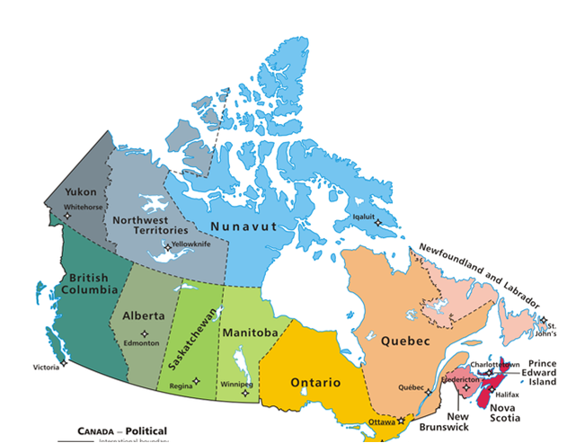

**Task 1: Прочитайте текст, озаглавьте каждый абзац.**

Canada is a vast country, bigger than the United States, bigger then the continent of Australia. It is in fact one of the world's largest countries as Canada extends for thousands of miles from the Arctic Ocean to the United States and from the Atlantic Ocean to the Pacific Ocean, all kinds of weather conditions and scenery are to be found there.

The word Canada comes from one of the Red Indian languages – "Kannata", meaning "a number of huts". Canada is often called the "Land of the Marple Leaf". The marple leaf is the national emblem of Canada.

The story of Canada goes back over 400 years. The French were the first settlers in this country. As far back as the 15th century, French explorers crossed the Atlantic, and sailed up the east coast of Canada. In the 17th century, several expeditions from France were sent out to explore the new country. This was the real beginning of Canada. Colonists were then sent from the mother country, and they built several large French colonies. The history of the country during this period is the history of daring explorations, wars with the Indians, and struggles against Great Britain and the British colonies in the south. In 1759, France lost Canada. Canada became a British colony. Later Canada was given its independence, but it remained a part of British Empire.

Today Canada is an independent federative state, consisting of 10 provinces and two territories. It is a member of the Commonwealth, headed by the Queen of Great Britain.

Canada's beginnings were French, and French is the national language spoken today by about one fifth of its people. Many settlers came to Canada from England, Scotland and Ireland, so today about two-thirds of the people of Canada speak only English. Canada today has two national languages, English and French.

**Task 2: Прочитайте тезисы, сформулируйте из них предложения.**

Capital – Ottawa

Type of Government – Monarchy, officially, Canada is a part of the UK, so, the Queen Elizabeth II is also the Queen of Canada.

National day – Canada Day (1 July), The Birthday of the British Queen is also a holiday.

Canada Flag

The Maple Leaf is a symbol of Canada.

The red colour symbolises courage.

National sport – hockey. Canada won the Hockey World Championship 24 times.

Canada has 14 provinces.

Largest cities - Winnipeg, Vancouver, Quebec City.

Nickname – the country of lakes and mountains.

National symbols: polar bears and the Royal Police Officers.

**Task 3: Расскажите о том, чем знаменита Канада.**

Canada is famous for

* its size, it is the 2nd largest country in the world after Russia.
* Beautiful nature and landscape, National Parks cover more than a half of Canadian territory. Banff National Park is the largest National Park in the world, it is so vast that all Europe can fit in.
* Niagara Falls, the biggest tourist attraction, 50m high, the highest vertical waterfall in the world.
* Outdoor sport , there are many ski resorts, popular activities include – fishing, hunting, swimming.
* Bear Lake – the 2nd largest lake in the world after Baikal.
* Rideau Canal in Ottawa is the largest skating rink in the world. It is 8 km long.
* Polar bears are a common sight in many Canadian regions. Many cars in Canada have number plates in a shape of a bear.
* Canadian police officers are famous for their colourful uniform.

**Task 4: Дополните предложения.**

CANADA QUIZ

___________________________ is the capital of Canada

___________________________ is the largest National Park in the world

___________________________ is the biggest tourist attraction in Canada

___________________________ is the 2nd largest lake in the world

___________________________ is the largest skating rink in the world

**Task 5: Ответьте на вопросы.**

1. Why is Canada “the country of lakes and mountains”?

2. What can you do if you visit Canada?

**Критерии оценивания:**

Выполнение заданий 1,2,3 низкого уровня – отметка «3».

Дополнительное выполнение задания 4 среднего уровня – отметка «4».

Дополнительное выполнение задания 5 высокого уровня – отметка «5».

### Практическая работа № 15 «Australia»

**Цель:** научить рассказывать о географическом положении Австралии, достопримечательностях и особенностях страны.

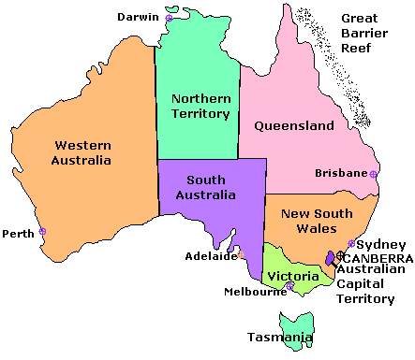

**Task 1: Прочитайте текст, озаглавьте каждый абзац.**

Australia is the only country in the world that is also a continent. It is the sixth large country and the smallest continent. Australia lies between the South Pacific Ocean and the Indian Ocean. It is situated about 11 000 km southwest of North America and about 8200 km southeast of mainland Asia. The name of the country comes from Latin word «australis» which mean southern. The country's official name is Commonwealth of Australia.

The Commonwealth of Australia is a federation of states. Australia has six states – New South Wales, Queensland, South Australia, Tasmania, Victoria and Western Australia. Each state has its government. Australia has two territories – the Australian Capital Territory and the Northern Territory. The capital of the country is Canberra.

Australia is a constitutional monarchy like Great Britain. The nation is administered under written constitution. The British monarch, Queen Elizabeth II, is also queen of Australia and country's head of state. However, the queen has little power in the Australian government. She serves mainly as a symbol of long historical tie between Great Britain and Australia. Australia is a member of the Commonwealth of Nations which is an association formed by Britain and some of its former colonies.

Australia is one of the world's developed countries. Australia has modern factories, highly productive mines and farms, and busy cities. It is the world's leading producer of wool and bauxite (the ore from which aluminium is made). It also produces and exports large amounts of other minerals and farm goods. Income from the export enables Australians to have high standard of living. The most important trading partners of Australia are Japan and the United States.

**Task 2:** **Ответьте на вопросы.**

1. Where does the Australia lie?

2. What is the official name of the country?

3. What is the capital of the country?

4. Who is the country's head of state?

5. Is there a written constitution in Australia?

6. What are the main products of Australia?

7. What are the most important trade partners of the country?

**Task 3: Прочитайте тезисы, сформулируйте из них предложения.**

Capital – Canberra, largest cities are Sydney, Melbourne

Type of Government – Monarchy, officially Australia is a part of the UK, so, the British Queen is the Queen of Australia

National day – Australia Day (26 January), the Queen Birthday is also a holiday

National symbol – kangaroo

Australia Flag



The British Flag in the left corner symbolizes an eternal union with the UK, one big star is Australia, 5 little stars stand for the Southern Cross.

National sport – surfing. Australia won World Surfing Championship 7 times.

Australia has 7 parts: Western Australia, Northern Territory, South Australia, Queensland, New South Wales, Victoria, Tasmania.

The most famous building in Australia is Sydney Theatre, it is in the shape of shell.

**Task 4: Расскажите о том, чем знаменита Австралия.**

Australia is famous because….

* it has unique fauna: kangaroo and koala live only in Australia.
* it is the only country that occupies the whole continent, Australia is one of 6 continents.
* Australia is under equator, it means its seasons are different from Europe, when we have summer it is winter in Australia, The coldest month is July, January is the warmest month.

June, July, August – winter, September, October, November – spring, December, January, February – summer, March, April, May – autumn. School in Australia starts in March and ends in November.

* Coral reefs, Great Barrier Reef is the world’s largest reef system, it is 3000 km long and includes 900 coral atolls.
* Australia is an ideal place for diving and sailing.

**Task 3: Дополните предложения.**

AUSTRALIA QUIZ

The capital of Australia is ___________________________________________

The most famous building in Australia is _______________________________

The symbol of Australia is __________________________________________

When we have summer, in Australia it is _______________________________

**Task 5: Ответьте на вопросы.**

1. What can tourists see and do in Australia?

2. What can you do if you visit Australia?

**Критерии оценивания:**

Выполнение заданий 1, 2, 3 низкого уровня – отметка «3».

Дополнительное выполнение задания 4 среднего уровня – отметка «4».

Дополнительное выполнение задания 5 высокого уровня – отметка «5».

### Практическая работа № 16 «English speaking countries»

**Цель:** обобщить знания о достопримечательностях и особенностях англоязычных стран в форме викторины.

***ROUND I - ON BRITAIN***

**1. What is the Union Jack?**

A-The national flag

B- Trade union organization

C-Monument

**2. What is the name of the present British Queen?**

A-Elizabeth I

B-Mary

C-Elizabeth II

**3. What is the capital of Wales?**

A-Glasgow

B-Cardiff

C-Edinburgh

**4. Where did the Beatles come from?**

A-Bristol

B-Manchester

C-Liverpool

**5. What is the song the Scottish people sing at the parties?**

A-“Jingle Bells”

B-“Should Auld Acquaintance Be Forgot”

C-“Greensleeves”

**6. Where does the ceremony of the Keys take place?**

A-In the Tower of London

B-At Buckingham Palace

C-In Trafalgar Square

**7. Which street in London is called “newspaper street?**

A-Oxford Street

B-Fleet Street

C-Downing Street

**8. Where is the Speaker’s Corner?**

A-In Richmond Park

B-In Hyde Park

C-In Kensington Gardens

**9. Where is the National Shakespeare Theatre?**

A-In London

B-In Birmingham

C-In Stratford-upon-Avon

**10. What is the national musical instrument of Scotland?**

A-Bagpipe

B-Trumpet

C-Guitar

***ROUND 2 - ON THE USA***

**1. Who of the presidents fought the abolition of slavery in the USA?**

A-Lincoln

B-Jefferson

C-Washington

**2. What river is New York situated on?**

A-The Mississippi

B-The Potomac

C-The Hudson

**3. What is the world’s tallest stone structure situated in Washington?**

A-Washington Monument

B-Lincoln Memorial

C-Palace of Justice

**4. Which kind of sport is a typical American invention?**

A-Tennis

B-Baseball

C-Golf

**5. Which holiday is celebrated on the fourth Thursday of November?**

A-Halloween

B-Independence day

C-Thanksgiving Day

**6. Who of the musicians played the trumpet in jazz?**

A-Wellington

B-Armstrong

C-Presley

**7. Who of the American scientists invented the telephone?**

A-Alexander Bell

B-Henry Ford

C-Martin King

**8. Who of the American writers wrote books under the name of Mark Twain?**

A-Jack London

B-Samuel Clemens

C-John Grisham

**9. Which street in New York is called the home of theatres?**

A-The 5th Avenue

B-Broadway

C-Fleet Street

**10. What is the traditional meal on Thanksgiving Day?**

A-Fish

B-Pudding

C-Turkey

***ROUND3 - ON AUSTRALIA***

**1. What animals eat eucalyptus?**

A-Dingo

B-Koala

C-Possums

**2. What flightless bird lives in Australia?**

A-Parrot

B-Emu

C-Eagle

**3. Which representative of Australian fauna doesn’t use eyes and ears under water?**

A-Platypus

B-Fish

C-Ducks

**4. Which Australian animals are born the size of a large bean and then grow taller than a man?**

A-Emu

B-Koala

C-Kangaroo

**5. Which of the Australian kangaroos are the largest?**

A-Brown and grey

B-Red and yellow

C-Green and red

**6. What animals often attack sheep and are dangerous for people?**

A-Wild dog dingo

B-Ostrich

C-Platypus

**7. Which animal is considered to be the king of Australian animals?**

A-Platypus

B-Dingo

C-Kangaroo

**8. Which of the Australian animals sleeps during the day?**

A-Emu

B-Koala

C-Wallaroos

**9. Which of the Australian bird is famous for its mocking laugh?**

A-Borkaburra

B-Wombat

C-Parrot

**10. Which marsupial looks like an enormous rat?**

A-Bat

B-Ostrich

C-Wombat

***ROUND 4 – ON NEW ZEALAND***

**1. Which of the islands in New Zealand is the most popular**

A-North Island

B-Stuart Island

C-South Island

**2. What reptiles do not live in New Zealand?**

A-Bears

B-Snakes

C-Wolves

**3. What is the nickname of New Zealand?**

A-Kiwi

B-Kakado parrot

C-Weka

**4. What is the nickname of New Zealanders?**

A-Maori

B-Kiwi

C-Islanders

**5. What was the first capital of New Zealand?**

A-Wellington

B-Dunedin

C-Auckland

**6. What are the two official languages in New Zealand?**

A-English and French

B-English and Maori

C-English and German

**7. How are Maori people characterized?**

A-Warlike

B-Peaceful

C-Independent

**8. Whom is the Queen of England represented by in New Zealand?**

A-Prince

B-Her Minister

C-Governor General

**9. What is the political structure of New Zealand?**

A-Constitutional Monarchy

B-Parliamentary Republic

C-Socialist State

**10. When do children begin to go to school in New Zealand?**

A-At the age of 7

B-At the age of 6

C-At the age of 5

***ROUND 5 - ON CANADA***

**1. What country does Canada border on in the North?**

A-The USA

B-Russia

C-Finland

**2. Which is the largest province in Canada?**

A-Quebec

B-Prince Edward

C-Ontario

**3. Which agricultural product grown in Canada is world famous?**

A-Flax

B-Wheat

C-Potato

**4. Which tower rises above the Parliament Building in Ottawa?**

A-Green Tower

B-Victoria Tower

C-Peace Tower

**5. Which museum in Ottawa illustrates the cultures of Eskimos and Indians?**

A-The Museum of Nature

B-Laurier House

C-The Museum of Civilization

**6. Which May festival is Ottawa world famous for?**

A-Tulip Festival

B-Art Festival

C-Music Festival

**7. The Queen of what country presents Ottawa with flowers?**

A-Great Britain

B-The Netherlands

C-Nepal

**8. In what town does 9-day winter festival Winderhide take place?**

A-Ottawa

B-Toronto

C-Montreal

**9. In what province is the Niagara Falls situated?**

A-Newfoundland

B-Ontario

C-Nova Scotia

**10. Which syrup is Canada famous for?**

A-Maple

B-Cranberry

C-Lemon

**Критерии оценивания:**

25–30 баллов – отметка «3».

31–45 баллов – отметка «4».

46–50 – отметка «5».